**DBMS-2 PROJECT WORK**

**Barat Nurbolat**

***Online Shopping***

***1.Description***

***i) A database is information that is set up for easy access, management and updating. Computer databases typically store aggregations of data records or files that contain information, such as sales transactions, customer data, financials and product information. My database project is about online marketing between customers and employers.***

***ii)Databases are used for storing, maintaining and accessing any sort of data. They collect information on people, places or things. That information is gathered in one place so that it can be observed and analyzed. Databases can be thought of as an organized collection of information. This system is performed to order in online shopping.***

**iii) End users are basically those people whose jobs require access to the database for querying, updating, and generating reports. The database primarily exists for their use. End users in this system are teachers, advisors and students.**

**iv)Data obsolescence is the loss of reliability and value of the information. The older the date of data collection or update, the more likely they become obsolete.Data recency refers to the length of time between data collection or update and use for marketing purposes. To handle data obsolescence these functions should be done:constantly updating the data, avoid data duplicates, make system easy to access for users.**

**2.Entity Relationship Design**

1. **ER Diagram: I used <https://app.creately.com/d/start/dashboard> to create a ER DIAGRAM**

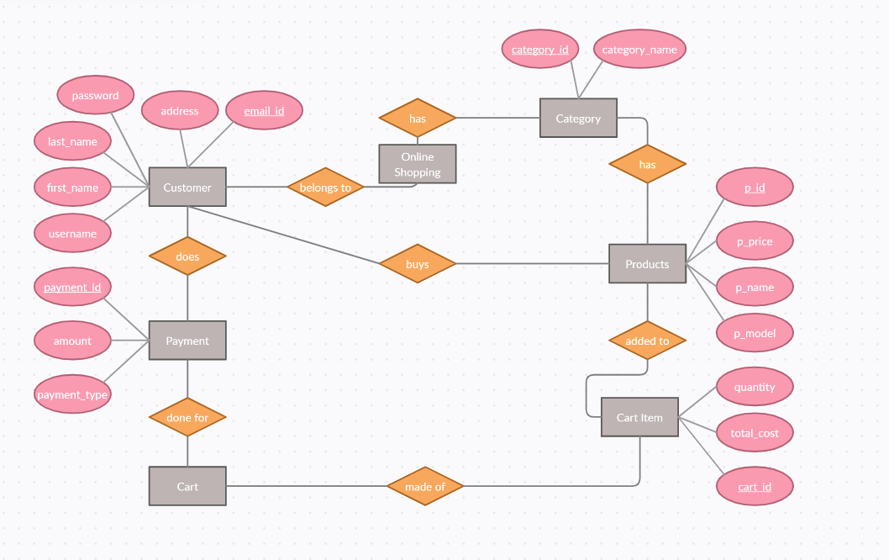 **ii) Rectangle : Entities**

**Rhombus : Relation**

**Rounds : attributes**

**Rounds with lines:Primary keys**

**iii) Explanation will be orally in front of teacher.**

**3.Normalization**

1. **Normalization is a database design technique that reduces data redundancy and eliminates undesirable characteristics like Insertion, Update and Deletion Anomalies. Normalization rules divides larger tables into smaller tables and links them using relationships. The purpose of Normalization in SQL is to eliminate redundant (repetitive) data and ensure data is stored logically.**

**Entities and their attributes**

**Customer ->username, first_name, last_name, password, address, email_id**

**Products -> p_id, p_price, p_name, p_model**

**Cart Item -> quantity, total_cost, cart_id**

**Payment ->payment_id, amount, payment_type**

**Category -> category_id, category_name**

**1nf:**

**Customer:**

|  |  |  |  |  |  |
| --- | --- | --- | --- | --- | --- |
| **User_name** | **First_name** | **Last_name** | **Password** | **Address** | **Email_id(primary key)** |
| **Teilob** | **Nurbolat** | **Barat** | **12345678** | **Almaty** | **Teilob@gmail.com** |
| **Bruno** | **Bruno** | **Elvarez** | **87011111** | **Astana** | **Bruno@gmail.com** |
| **Ghoul** | **Shadow** | **Fred** | **zxczxczxc** | **Shymkent** | **ZXC@gmail.com** |
| **Ghoul** | **Shadow** | **Fred** | **zxczxczxc** | **Shymkent** | **Ghoul@gmail.com** |

**2nf:**

**Payment:**

|  |  |  |
| --- | --- | --- |
| **Amount** | **Payment_type** | **Email_id(pk)** |
| **1** | **Mobile payments** | **Teilob@gmail.com** |
| **2** | **Credit cards** | **Bruno@gmail.com** |
| **3** | **Debit cards** | **Teilob@gmail.com** |

|  |  |
| --- | --- |
| **Payment_id(pk)** | **Email_id(fk)** |
| **123** | **Teilob@gmail.com** |
| **256** | **Bruno@gmail.com** |
| **378** | **Teilob@gmail.com** |

|  |  |  |
| --- | --- | --- |
| **Payment_id(pk)** | **amount** | **Payment_type** |
| **123** | **1** | **Mobile payments** |
| **256** | **2** | **Credit cards** |
| **378** | **3** | **Debit cards** |

**3nf:**

**Products:**

|  |  |  |  |
| --- | --- | --- | --- |
| **P_id(superkey)** | **P_price** | **P_name** | **P_model** |
| **111** | **$10** | **Cold_Tea** | **Tea** |
| **222** | **$15** | **Workester** | **Sauce** |
| **333** | **$40** | **Burger** | **Fast-Food** |

**4.Physical Design**

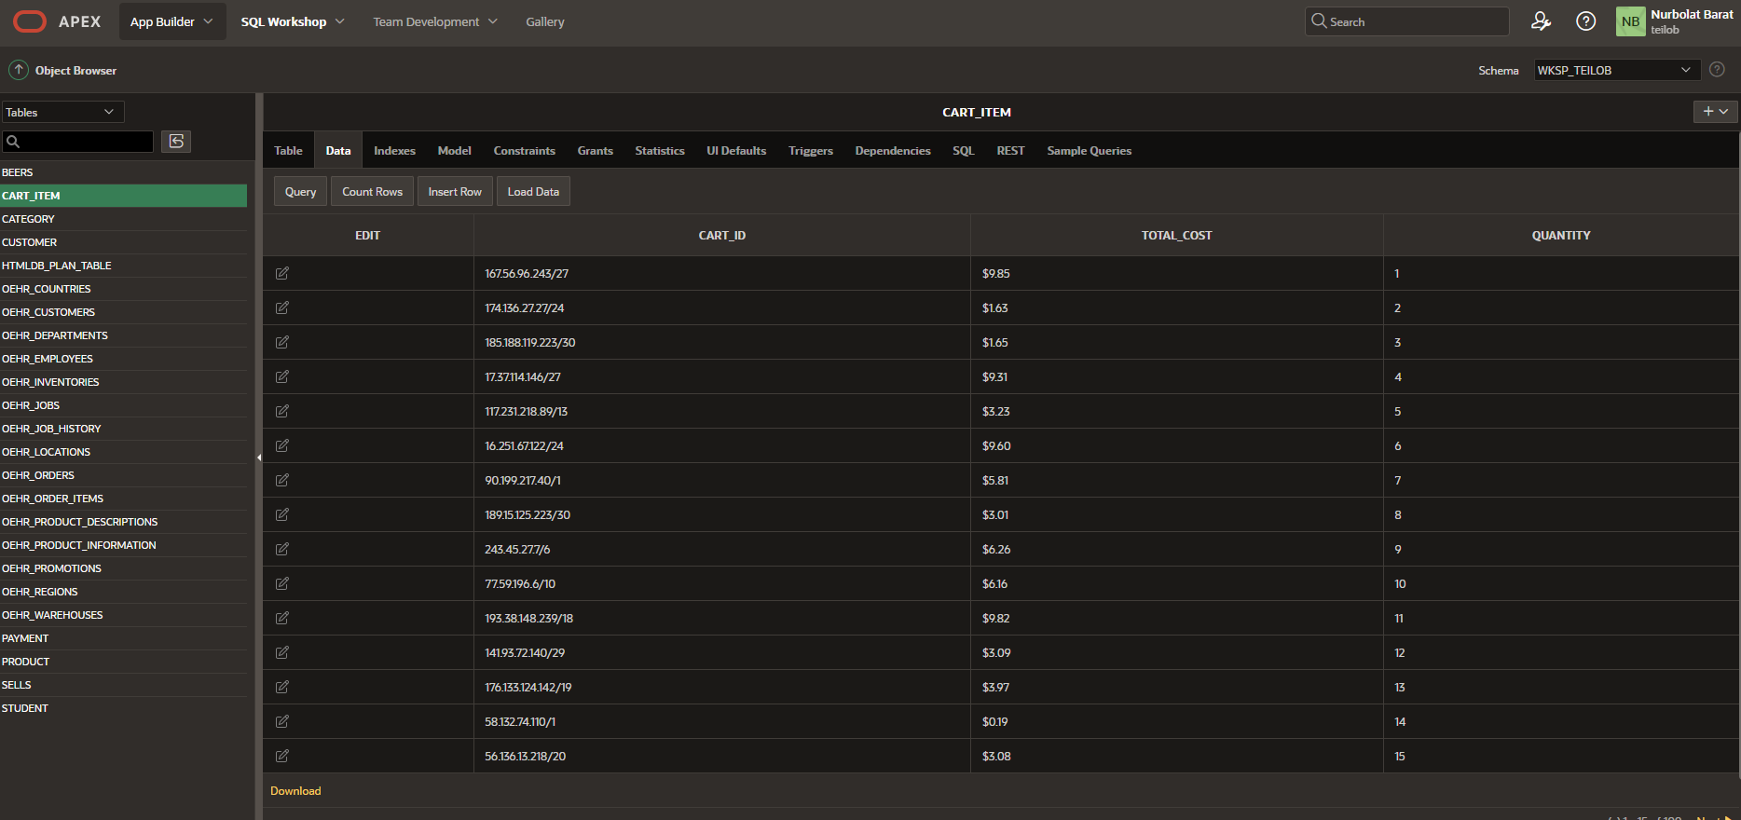

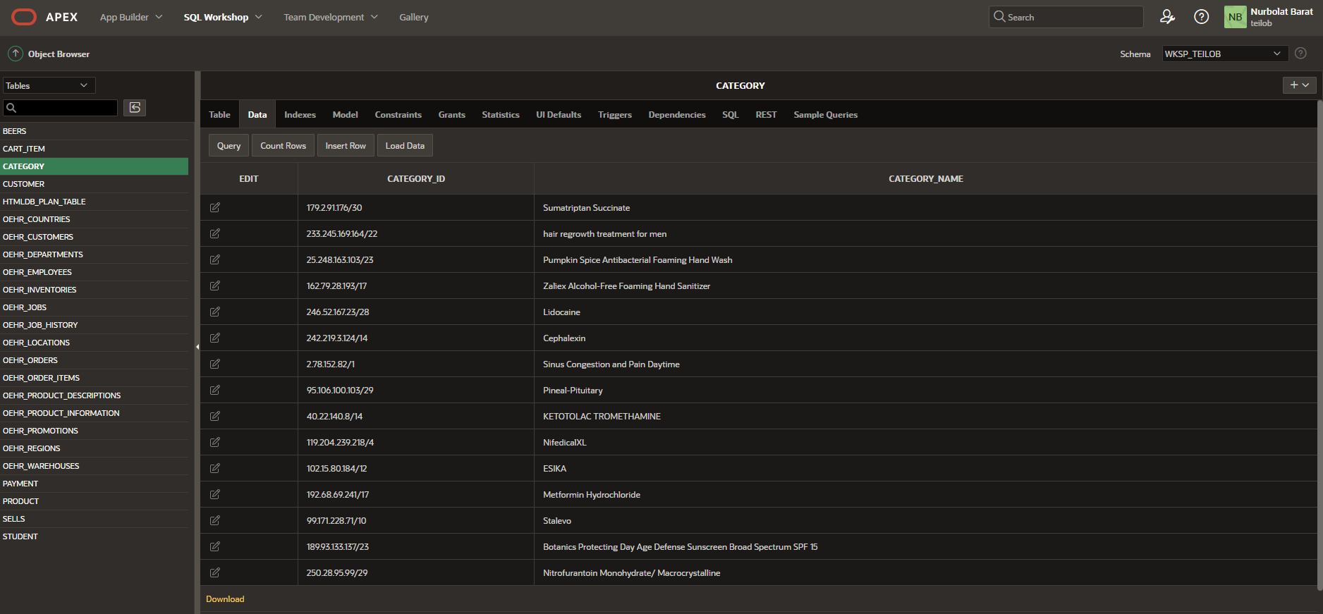

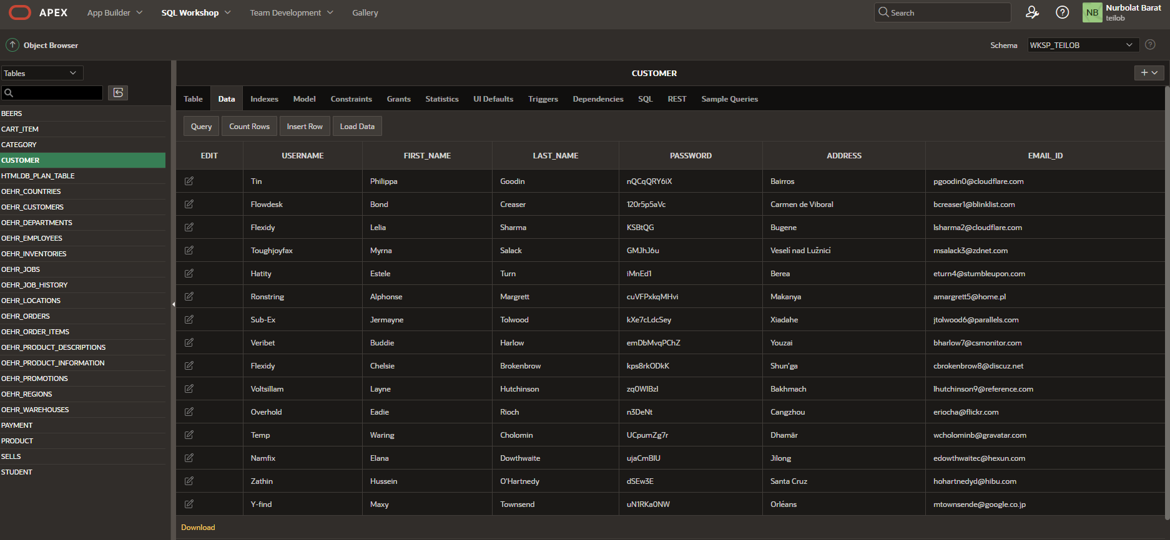

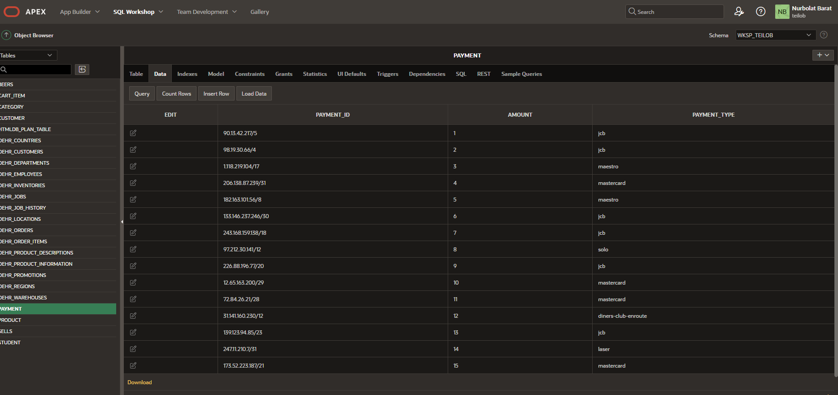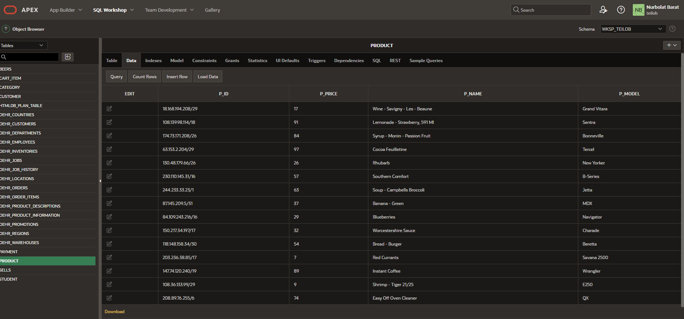

**5.Queries**